Graphics Design

II

Class vii

Lab 21

**Lab Objectives:**

* Offline Graphic Designing
* Creating a Project

Offline Graphic Designing

In previous lecture we have learned some tool names for graphic designing. But these are not beginner friendly. Most of them are used by professionals. But today you will be introduced with Microsoft PowerPoint which is not really a graphic designing software, but it is too easy to design any poster using PowerPoint.

Ideas

Suppose you have a burger shop. For a promotional purpose you make an offer that, if any one buy one burger you will give him another burger for absolutely free. So you want to launch a “Buy One Get One Free” campaign. So you will be going to create a poster about your burger’s promotion.

About Your Project

Header: header is a sentence which stands on the top of the poster. Suppose your header is “Best Burger in Town”.

Main: Main portion denotes which thoughts you want to share through the poster. Suppose “Buy One Get One @taka 230”

Footer: it stands on the bottom of a poster. Previously you used “please save our Sundarban” which was a footer.

Remember, Header and footer are not the mandatory thing you have to use. It’s totally optional. When you will design a poster just remember it is a graphical version of your thinking, imagination.

Burger Marketing Project

Right click to an empty space on your desktop. Go to new and click MS PowerPoint Presentation

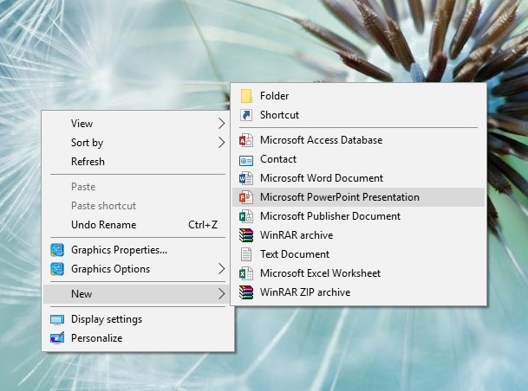

Name this file as you wish and click on it you will see a page like this.

Click on it.

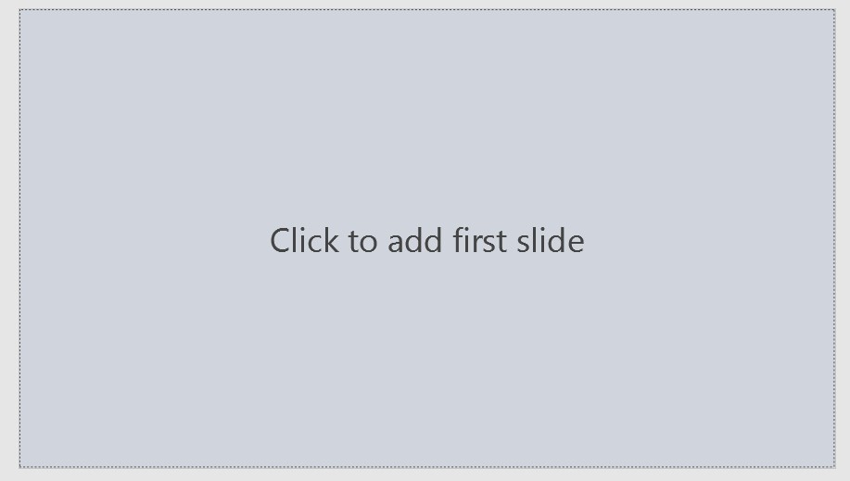

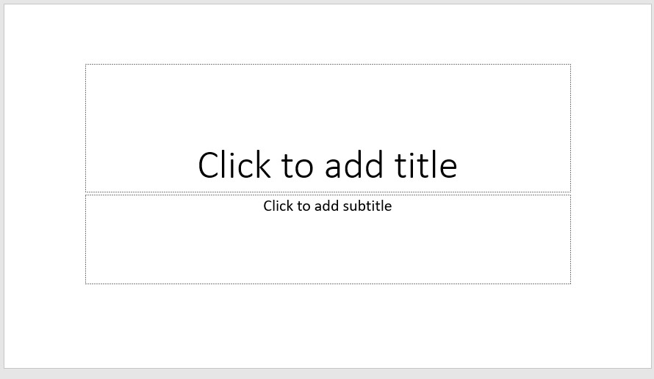After clicking you will see this slide.

Press Ctrl+A+Delete to remove text border.

You will see an totally empty slide like this.



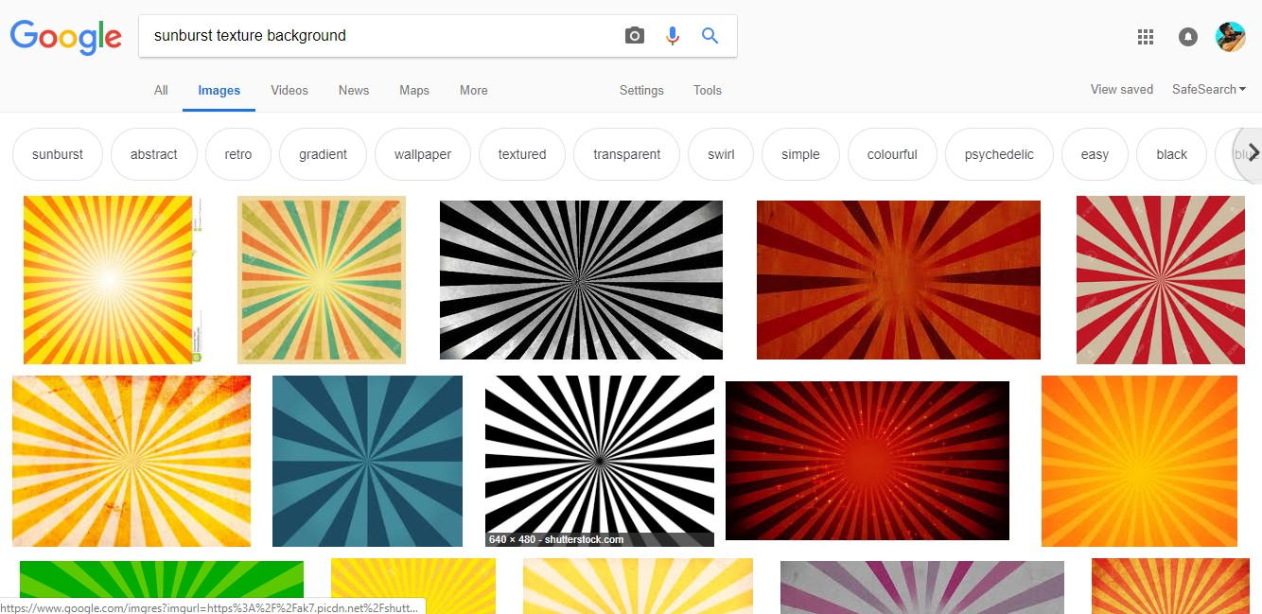No go to Google and search image by typing “sunburst texture background”. Click one of them, right click and copy this.

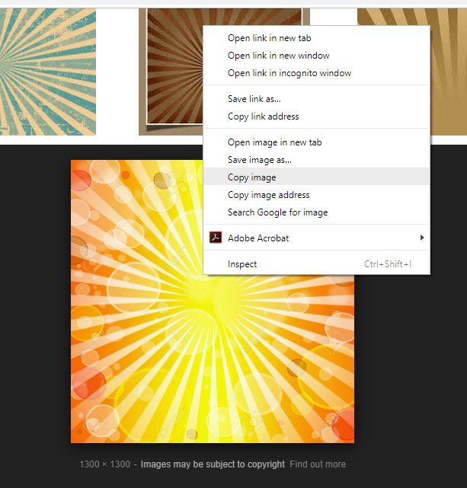

After copying that image, go to your empty slide and press Ctrl+v to paste it. The slide size and picture size may not be the same. To the bottom right corner there is option for resizing. Resize your image 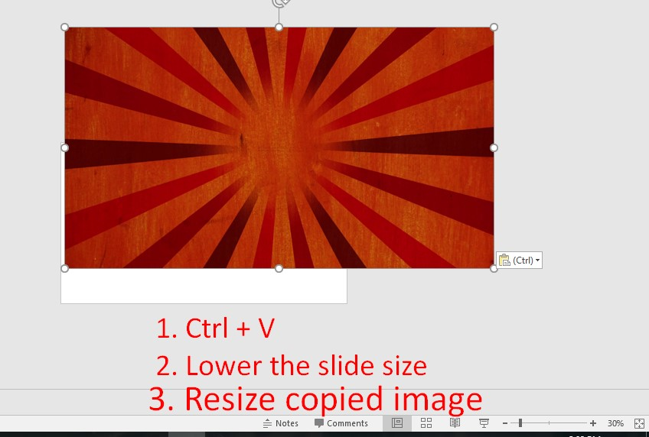according to slide size.

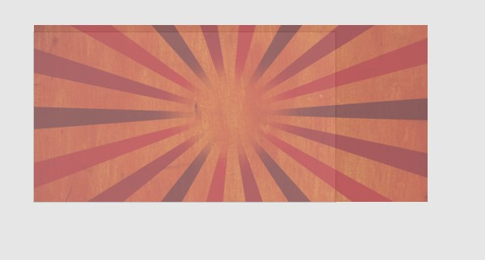

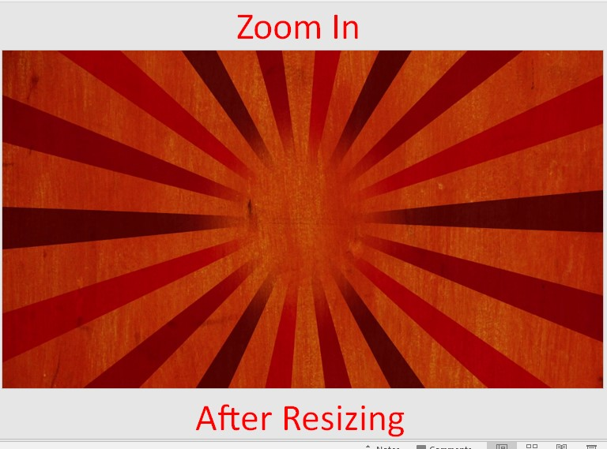

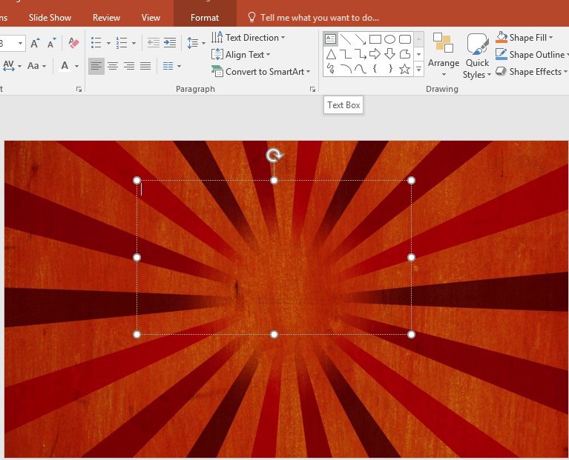

Click on text box to add header of this poster. Text box is appeared on the top. Click text box and then click anywhere of your background. Write “Best Burger in Town”.

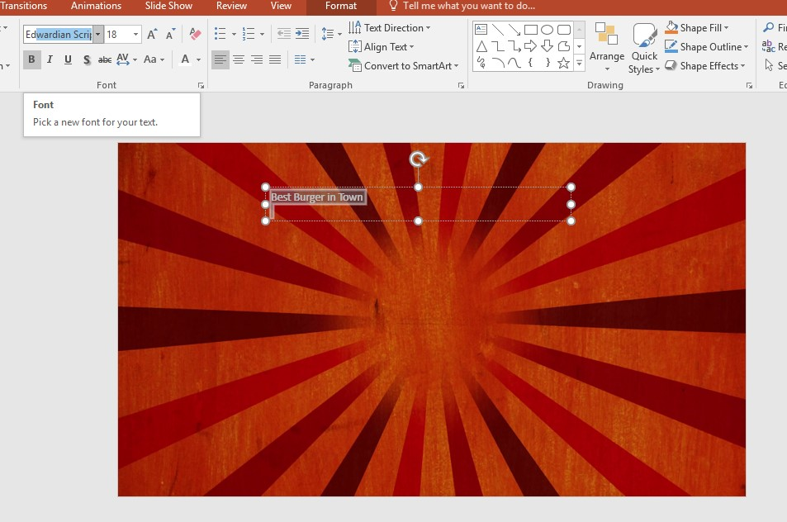

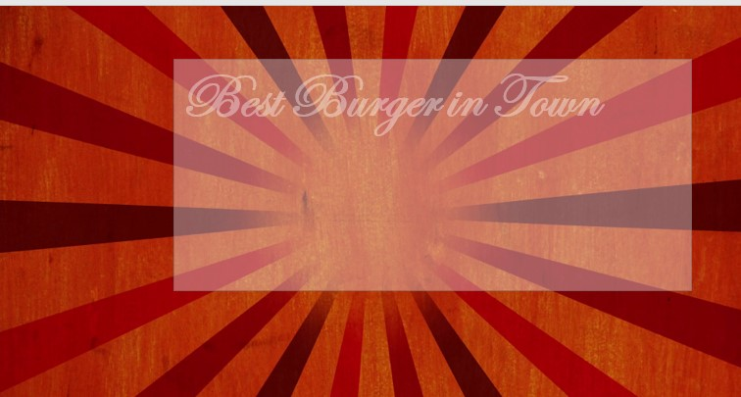For making it more beautiful change the font to Edwardian Script and change the font size to 80. Put this header to the middle top of the poster.

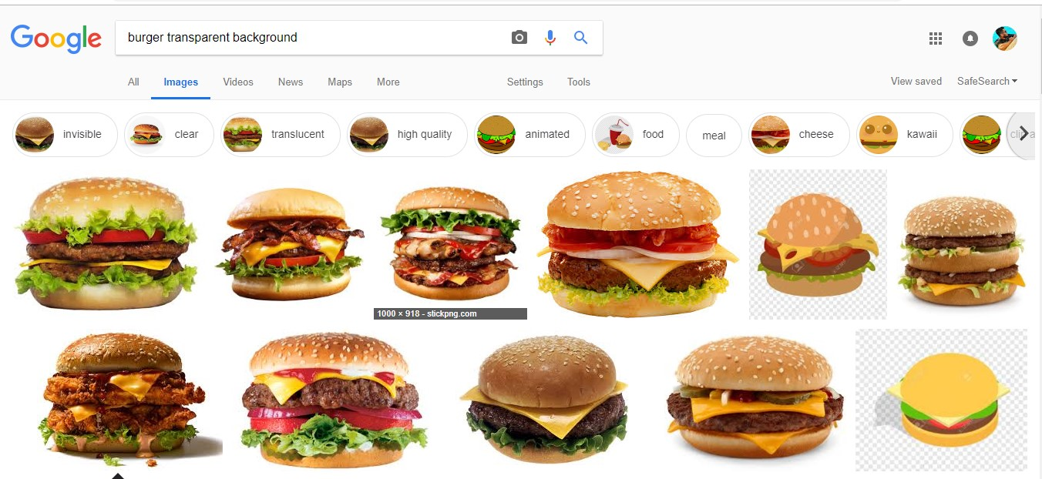again go to Google and search “transparent Background Burger” , pick one of them, copy and paste it to your slide.

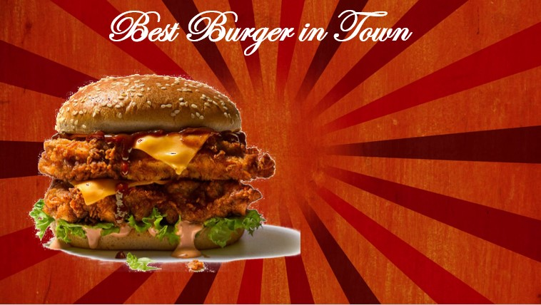wow! Looking nice. Press Ctrl+v again because we want to show twin

burger. Go to Google again and search “buy one get one free png”

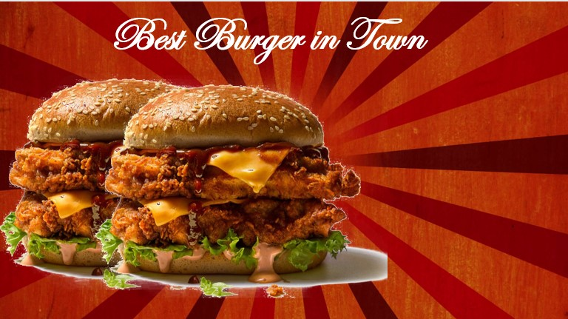

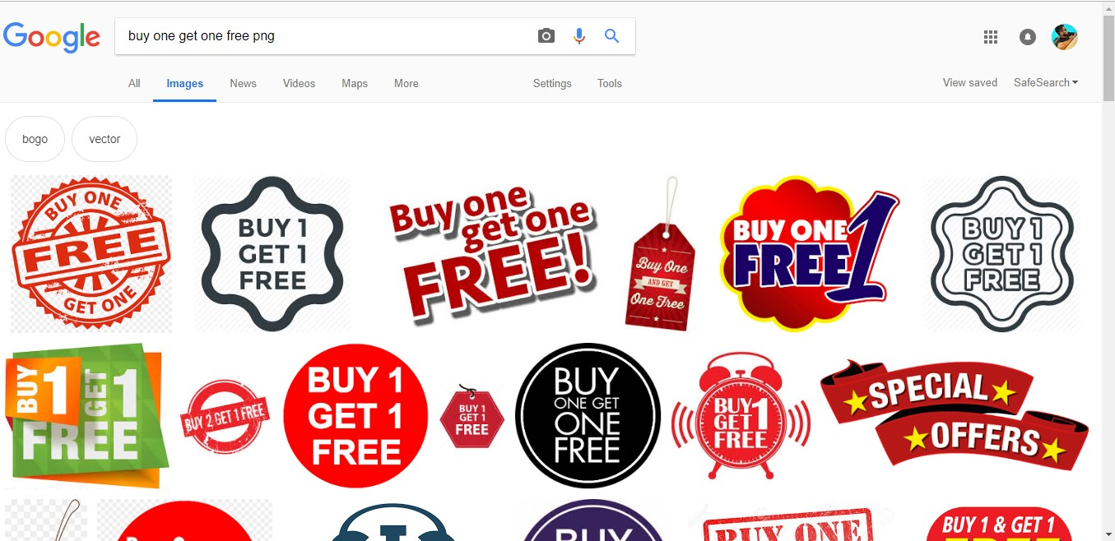

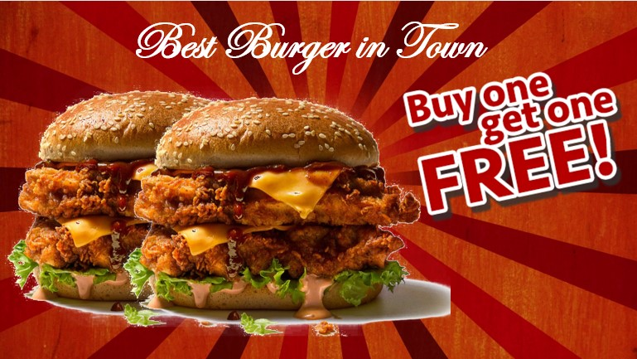Copy one of them and paste it to your slide.

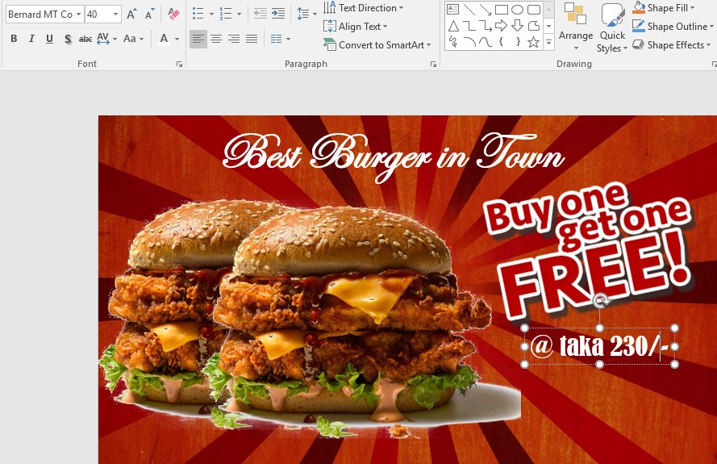Click on text box to mention your price. Suppose it’s 230 taka.

We used font Bernard MT Condensed with size 40. Finally, we get

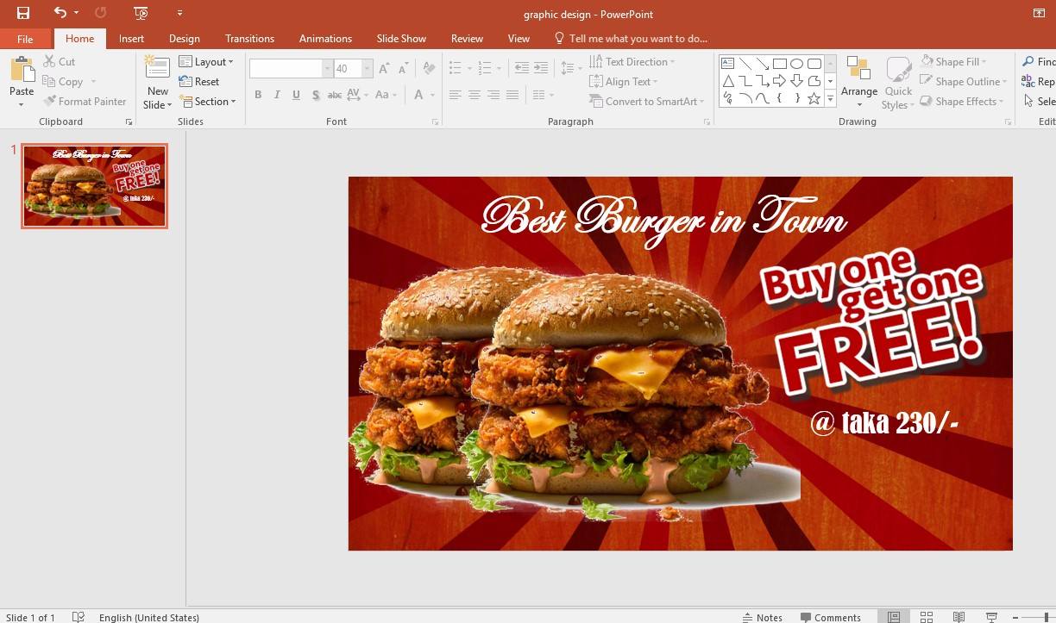

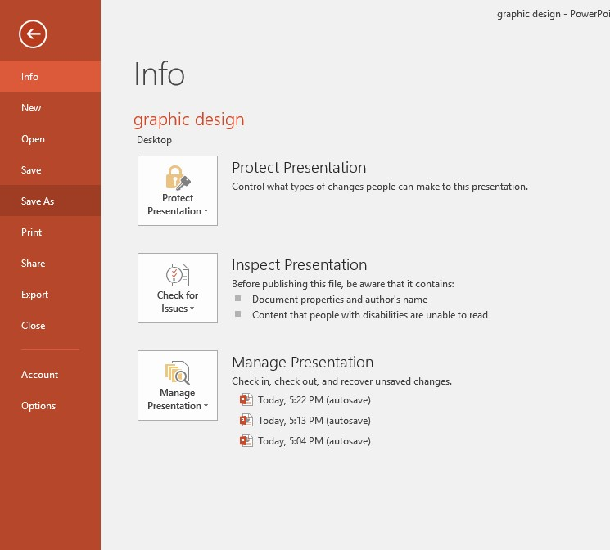Our poster is ready. Now it’s time to export as an image file. Click on file from the top left corner of your pc. Then click on Save As

Click desktop as we want to save it on our desktop.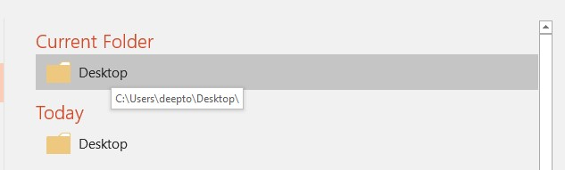

write your file name. We will change file type from PowerPoint Presentation to JPEG. So click on save as type

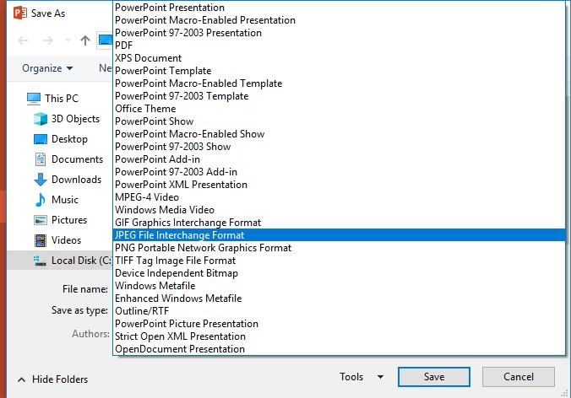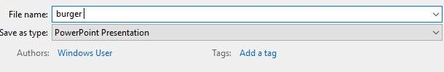

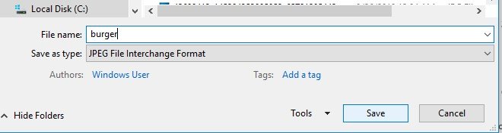

Click save and export by clicking “Just this one”. Now Go to your desktop You will get your poster.

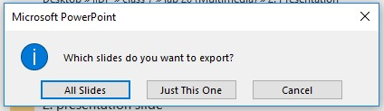

Here we go!! Graphic design is more than fun

